­­21CY681– Internet Protocol lab

Name: Akhil K J

Register Number : CYS22009

Title: Application of Cryptogrpahical Algorithms using Socket programming

Date of Assignment provided: 26/12/2022

Aim: To study about bittorrent and to analyse using wireshark

**Normal Client and Server Connection**

This is the python program for server for establishing a connection between client and server

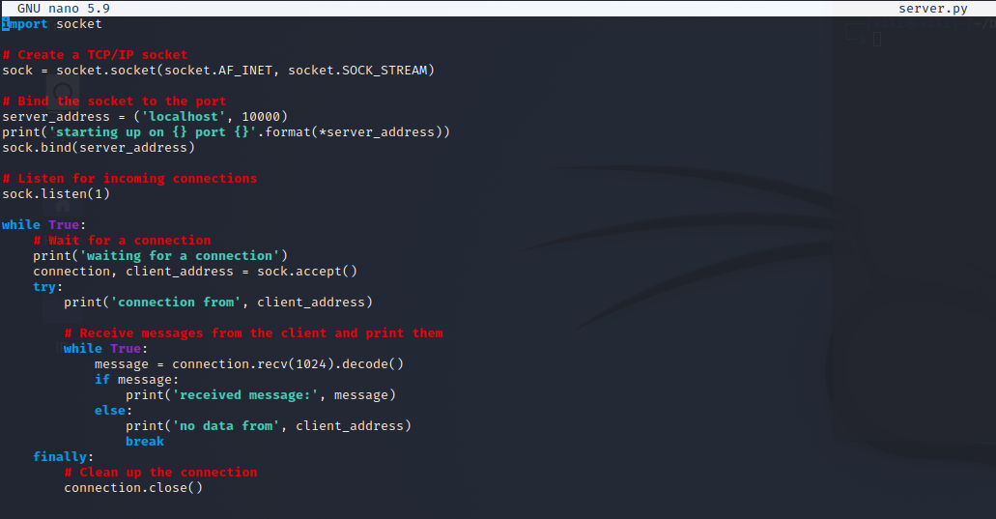

This is the python program for client for establishing a connection between client and server

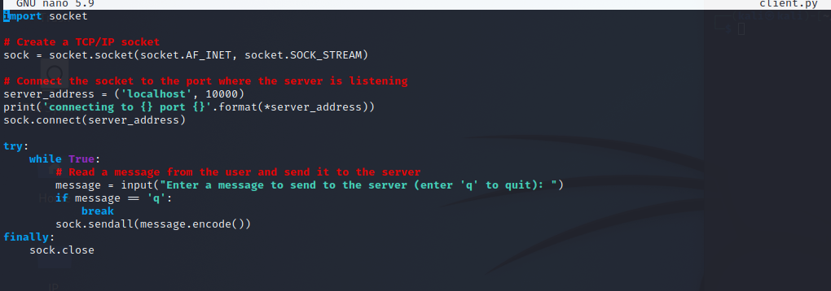

This is the scapy captured pcap which is being shown in wireshark.

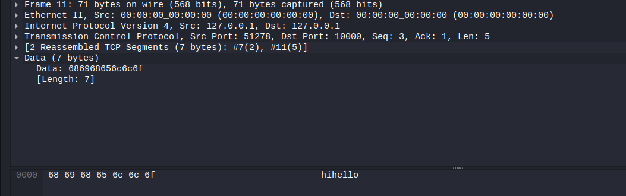

**Client and Server connection using RSA Encryption key**

This shows a python program for the server where RSA encryption key is being used to make the message encrypted.

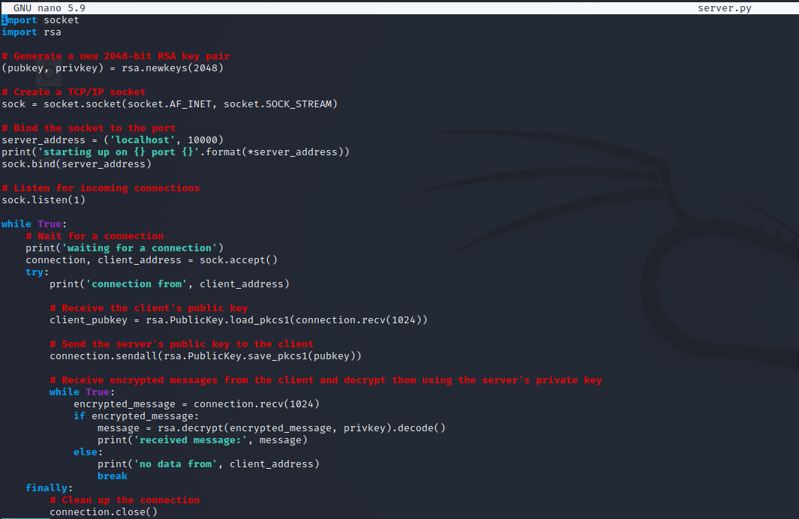

This shows a python program for the client where RSA encryption key is being used to make the message encrypted.

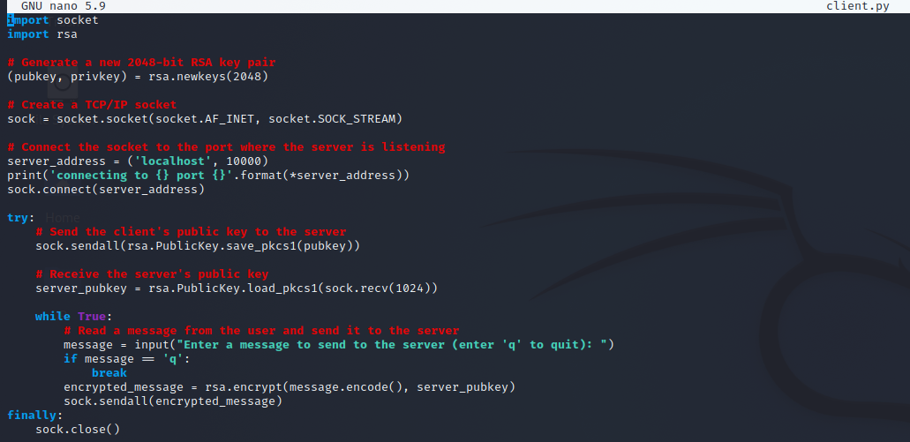

Now we are using Scapy which is a tool used here to capture the traffic between the client and server.

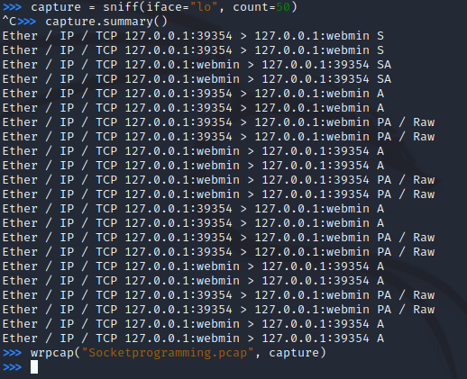

When the client program and server programs is running in parallel, the connection is being is made and the message is being sent.

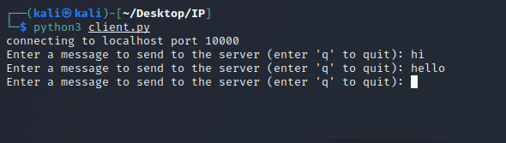

When the server is connected it receives messages from client.

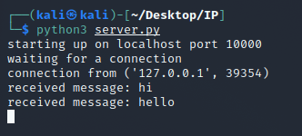

The scapy captured file is being saved it. The same pcap file is opened in Wireshark.

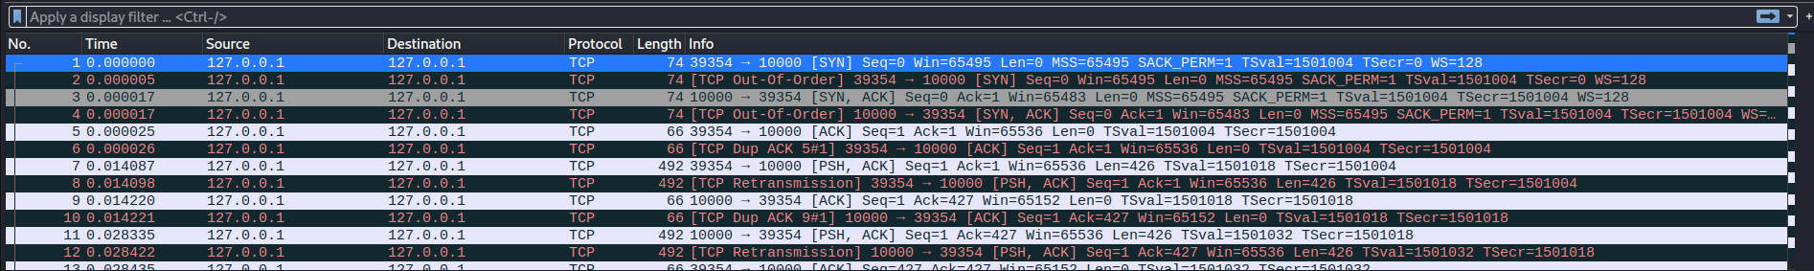

When we open a file we get the data.12

